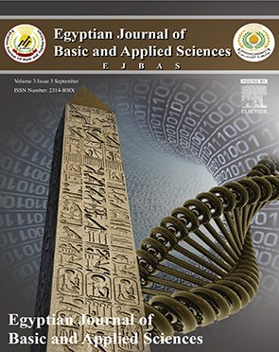 HOSTE D BY

Available online at [www.sciencedirect.com](http://www.sciencedirect.com/science/journal/2314808X)

**ScienceDirect**

journal homepage: [http://ees.elsevier.com/ejbas/default.asp](http://http//ees.elsevier.com/ejbas/default.asp)

**Full Length Article**

**Comparative study between well logging and core analysis of Hawaz reservoir in Murzuq Basin, Libya**



***Adel K. Mohamed*** ***a******,******\*******, Adel Kashlaf*** ***b***

a *Department of Geology, Faculty of Science, Mansoura University, Egypt*

b *Engineering Geology Department, Faculty of Natural resources, Zawia University, Libya*

A R T I C L E I N F O A B S T R A C T

*Article history:*

Received 29 April 2016

Received in revised form 4 July 2016 Accepted 13 July 2016

Available online 21 July 2016

*Keywords:*

Hawaz

NC-186 concession Murzuq Basin

Petrophysical characteristics

Murzuq Basin is one of the most important basins in Libya. It has many oil fields; H-field is one of the new discoveries in NC-186 concession in Murzuq Basin, Libya. This field has been affected by the structural and tectonic movements of Murzuq Basin and created paleo- high during the post-Hawaz erosional events. Ten exploratory wells were drilled for that field and well logging data were collected. The well logging data include Self potential, Gamma ray, Calipee, Resistivity, and Porosity logs (sonic, neutron, density). The recorded well logging data have been used for quick look interpretation and then correlated with both core data report and the plotted crossplots. The quick look results indicate that this reservoir is clean, highly porous and permeable. This reservoir is divided into 8 units/horizons (from H1 to H8), which are mainly sandstone with few intercalations of clay. Both well logging and core data are highly concordant. The results of the petrophysical characteristics have ascer- tained that H4–H6 are oil bearing zones while H7–H8 are water bearing horizons.

© 2016 Mansoura University. Production and hosting by Elsevier B.V. This is an open access article under the CC BY-NC-ND license (<http://creativecommons.org/licenses/by->

nc-nd/4.0/).

# Introduction

The area of study is located in Murzuq Basin and covers a huge area extending southward into Niger [1]. This area is one of the Murzuq oil fields and it is called H field. It is located in concession NC186 that was encountered by several exploratory and development wells, distributed on the northwestern flank of Murzuq Basin, southwestern part of Libya (Fig. 1). It has been affected by the structural and tec- tonic movements of Murzuq Basin and created paleo-high during the post-Hawaz erosional events. This feature of paleo- high is clearly represented in the 2-D seismic line shown in

Fig. 2 by Repsol Oil Operation [2] represented in the area of study. On the other hand, structure contour maps have been carried out for H field and illustrates the same structural feature of paleo-high (Fig. 3). The petroleum system is repre- sented by structural Hawaz paleo-high created during the post-Hawaz erosional event, the main regional seal is the Silurian Tanezzuft shale formation, and the basal Tanezzuft hot shale member displays also as the main source rock in the area of study. Ten exploratory wells distributed in H oil fields in concession NC186 will be the focus of this study. These wells were drilled in Hawaz reservoir of Middle Ordo- vician. This formation is informally subdivided into 8 horizons, named H1 to H8. Some units have been subdivided into

* *Corresponding author.*

*E-mail addresses:* [mohamedemamm79@yahoo.com](mailto:mohamedemamm79@yahoo.com), [adelkamel@mans.edu.eg](mailto:adelkamel@mans.edu.eg) (A.K. Mohamed). <http://dx.doi.org/10.1016/j.ejbas.2016.07.003>

2314-808X/© 2016 Mansoura University. Production and hosting by Elsevier B.V. This is an open access article under the CC BY-NC-ND license ([http://creativecommons.org/licenses/by-nc-nd/4.0/).](http://creativecommons.org/licenses/by-nc-nd/4.0/))

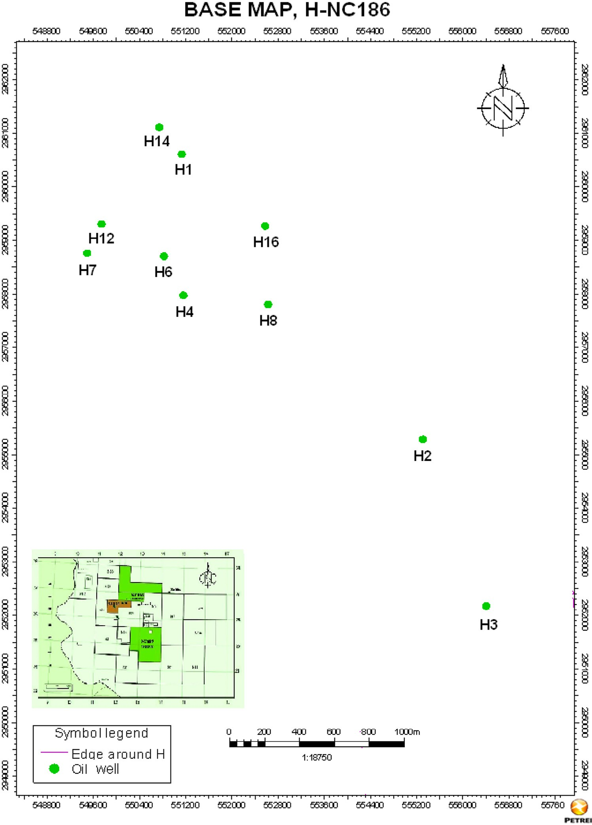

**Fig. 1 – Location map of the concession 186, Murzuq Basin, Libya.**

sub-units. Each horizon is characterized by its own petrophysical parameters.

This research paper is carried out as an extension to the previous studies [3] to analyze the petrophysical characteris- tics of Hawaz formation in H oil field, but here it will be focusing mainly on the quick look analysis of log curves and plotting crossplots between the petrophysical parameters and then compare the results with core data. The following data have been taken to achieve the objectives of this research: The geo- logical data are represented by composite logs. The well logging data comprise resistivity, sonic, neutron, density, spontane- ous potential, caliper, gamma ray and natural gamma ray spectrometry logs. These data have been taken from Repsol Oil

Operation [2], where the core data are represented by an in- ternal report.

# Geologic background

Murzuq Basin is one of the most significant basins in South- western Libya. This basin has a triangular shape and extended toward the border of south from Libya with Niger. The sedi- mentary fill is predominately Paleozoic in age, while the Mesozoic and Cenozoic sediments are also represented and located above the Precambrian crystalline basement (Fig. 4).

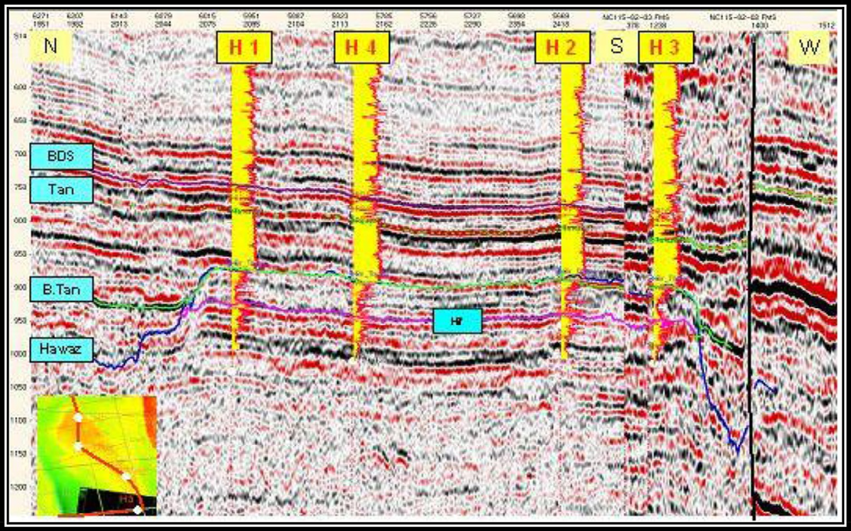

**Fig. 2 – 2-D seismic line for H1, H4, H2 and H3, H-field NC186 wells, Murzuq Basin** **[2]****.**

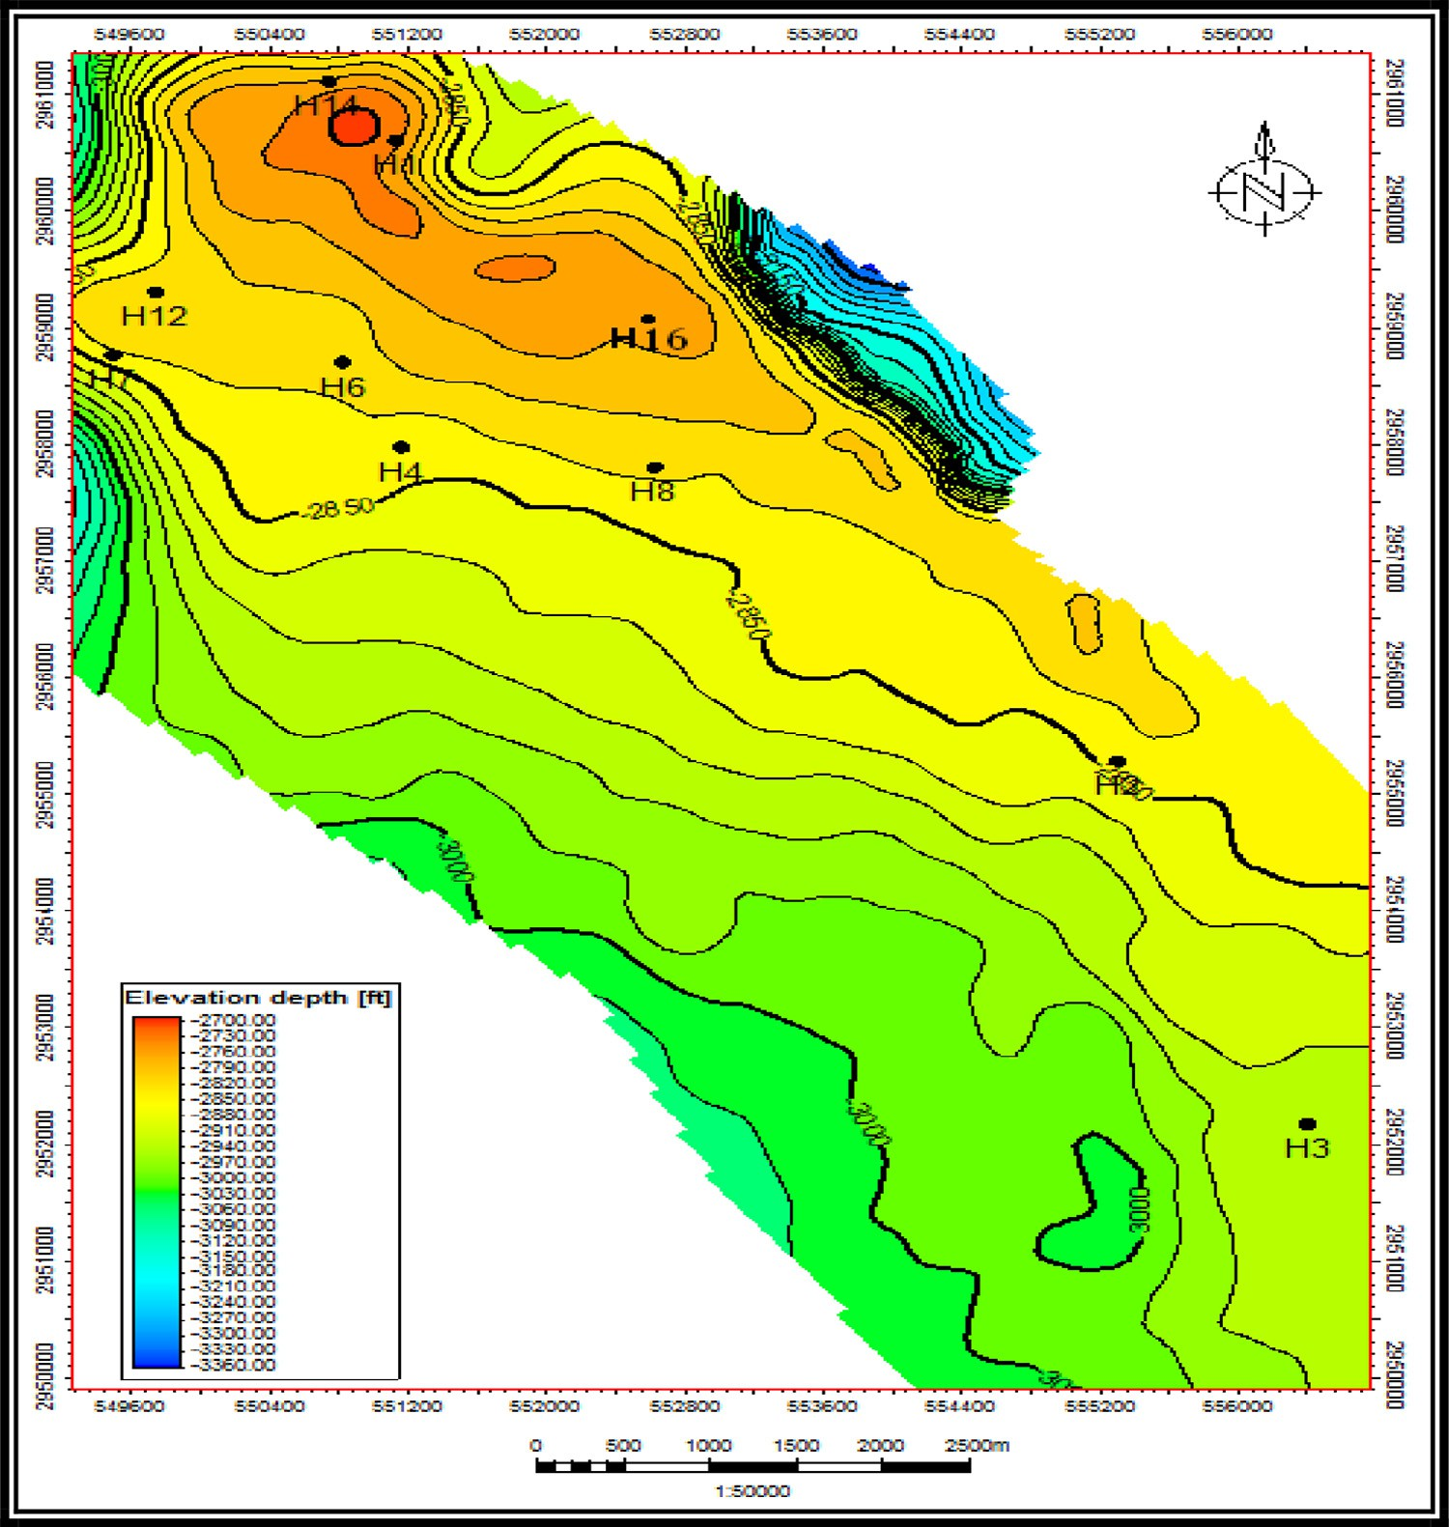

**Fig. 3 – Structure contour map for Hawaz reservoir in H field.**

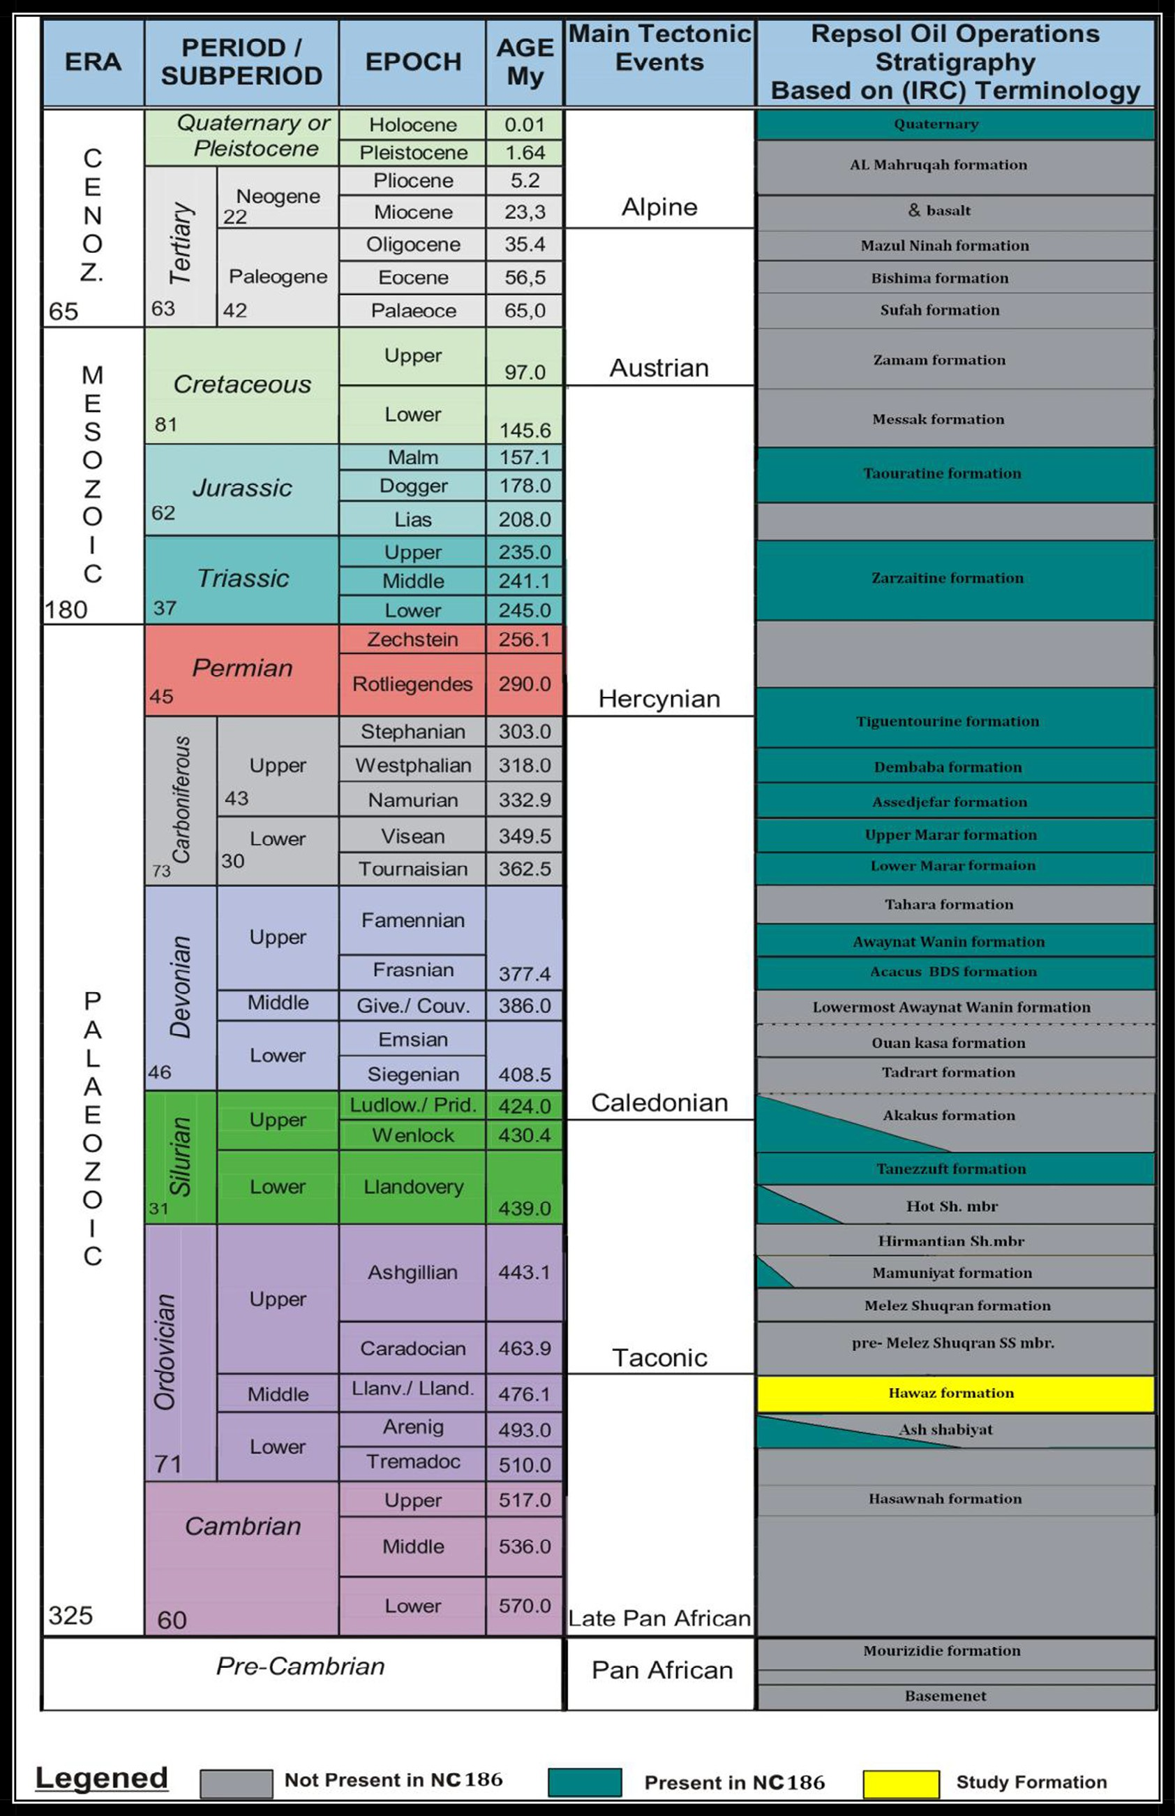

**Fig. 4 – Stratigraphic column of H oil field, NC186, NW Murzuq Basin, Southwestern Libya** **[4]****.**

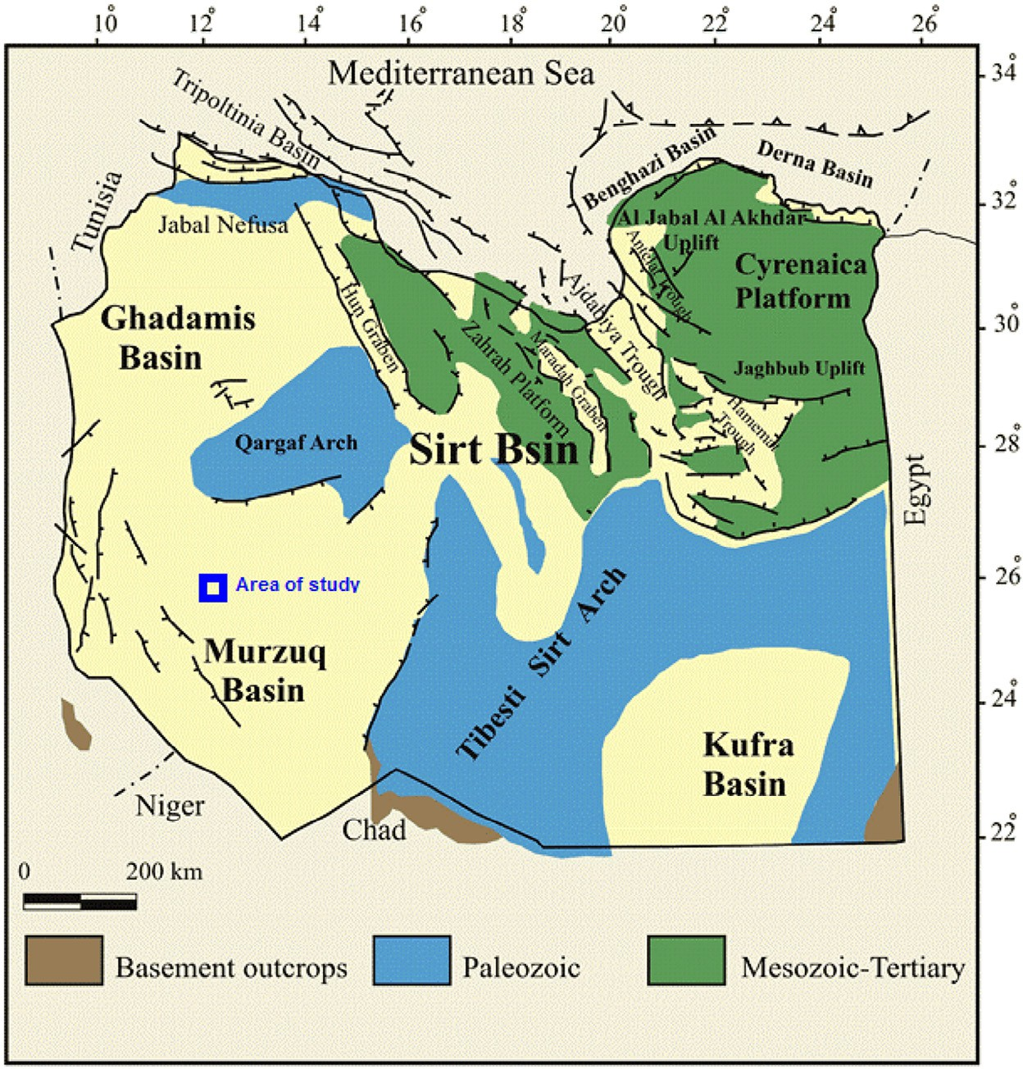

**Fig. 5 – Tectonic map of Libya including Murzuq Basin** **[4]****.**

This basin has a sedimentary sequence exceeding 3500 m in the central part of the basin [1]. Murzuq Basin is separated from Algeria basins to the west by the north-south ridge of the Ghat/ Tikiumit Arch [5,6]. It is located between three tectonic elements: the Qarqaf uplift in the north, the Tibesti/Haruj uplift in the east and the Precambrian Hogger on the west, which extends into Algeria and Niger. The whole sedimentary succession is well exposed along much of the edge of the basin as well as on the southern flank of the Qarqaf Arch. The full sedimentary suc- cession is present in few outcrop areas due to regional erosion connected with the Caledonian and Hercynian orogenies, and other lesser unconformities affecting all formations. In the core of the Qarqaf arch the crystalline basement outcrops in rela- tively small areas. The structure of Murzuq Basin is quite simple. The sub-horizontal or gently dipping strata is faulted and the faults are most frequently parallel to the axis (Fig. 5). Tectonic movements affected the basin to a greater or lesser degree from middle Paleozoic (Caledonian) to Post-Oligocene (Alpine) times [4]. Libya is divided into four Paleozoic and one Mesozoic basins. The first geologists working in western Libya established the broad stratigraphic framework of the Murzuq Basin [7]. The work of Pierobon [8] represents important steps in the advance- ment of our knowledge of this basin [9,10].

# Analysis of reservoir properties

The well logging data have been corrected first from the dif- ferent borehole environments. Then these data with core

samples recorded have been carried out utilizing quick log in- terpretation and analytical crossplots for evaluating the petrophysical characteristics of Hawaz reservoir.

## *Quick look interpretation*

Fig. 6 represents selective examples of the log curves for H1- NC186 well. This quick look analysis will focus on H1 well for abbreviation. Hawaz formation is subdivided into eight hori- zons (H1–H8). Separation between neutron (NPHI) and density (RHOZ) curves, together with gamma ray (GR) reading, re- flects the matrix and shaliness nature of the investigated interval. Also, deep (RLA5) and shallow (RXOZ) resistivity curves can tell about the presence of permeability and movable hy- drocarbons when correlated with porosity logs. The high reservoir quality is clearly seen on H5 and H6. Through these horizons, resistivity has high positive separation (RLA5 much higher than RXOZ), indicating probably the presence of high permeability and movable hydrocarbons (yellow color coded). The sandstone nature of this reservoir is observed from the separation between density (red color) and neutron (green color) log. The very low GR reading reflects the clean nature of the reservoir. Porosity can also be picked directly on the midway between density and neutron curves and read on the neutron porosity scale. It is 15% for these horizons (H5–H6). The water zone is clearly seen at the lower part of H8 where there was a sudden change in resistivity to the lowest value (Rt = 6 Ω·m). This value is considered to be Ro; hence, the zone is ex- pected to be 100% water saturated and the lithology is also clean

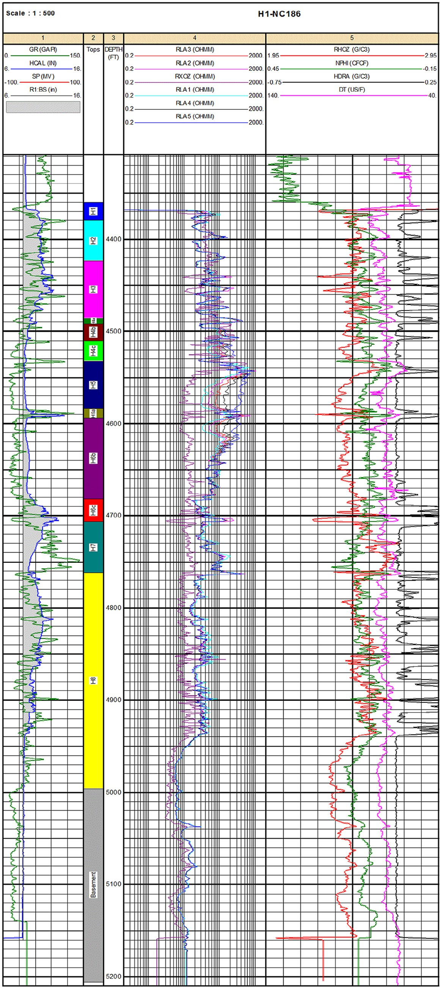

**Fig. 6 – Selective examples of the log curves for H1-NC186 well.**

sandstone with porosity equal to 18%. Applying Archie and Humble equations yield:

## *Reservoir fluid pressure gradient (λ) and density (ρ)*

Formation pressure has been plotted versus depth and has given

F  0.62  0.62  24.7

2.15 0.182.15

Rw  Ro  6  0.24   m

(1)

(2)

particular trend lines. Each line has definite gradients or slopes (λ). Each line represents definite fluid type and density ( ** *f* ). The contact between the two fluids can be picked at the intersection of the two lines of these fluids. The data of pressure from H1, H2,

F 24.7

The most striking and embracing feature is that the core result for this well gives Rw value of 0.3 Ω·m, which is in close correlation with the value 0.24 Ω·m obtained through the above described quick look technique. Also the Pickett plot de- scribed later gives a value of 0.32, which also agrees with the prescribed procedure. It is important to give more support and validation of the quick look method through calculating Sw. In the oil zone (H5), porosity is 15% and Rt is 400 Ω·m; hence,

H3 and H4-NC186 wells have been used and presented in Fig. 7. The plotted points clearly follow two trend lines corresponding to two types of fluids present, which are oil and water. The in- tersection between the two lines shows the contact between the two fluids, which is oil–water contact. The O.W.C is well-matched with that deduced from well logging response particularly re- sistivity log. Since the pressure data follow the same trend lines, it indicates that Hawaz reservoir in H1, 2, 3 and 4 wells is hy-

draulically connected. The fluid density is related to λ [11]:

water saturation can be calculated as

**f  * * **

0.433

(5)

Sw    0.12 12%

Ro

Rt

6

400

(3)

The calculated slopes and densities for these lines are as follows:

0.62  0.24

0.152.15  400

Sw 

0.62  *Rw*

2.15  *Rt*



 0.15 15%

(4)

**1  70  0.35

200

Again, the result is impressive because points representing

* * ** 0.35

(6)

*o*    0.8 g/cc

this horizon were plotted below 25% Sw line of the Pickett plot.

0.433 0.433

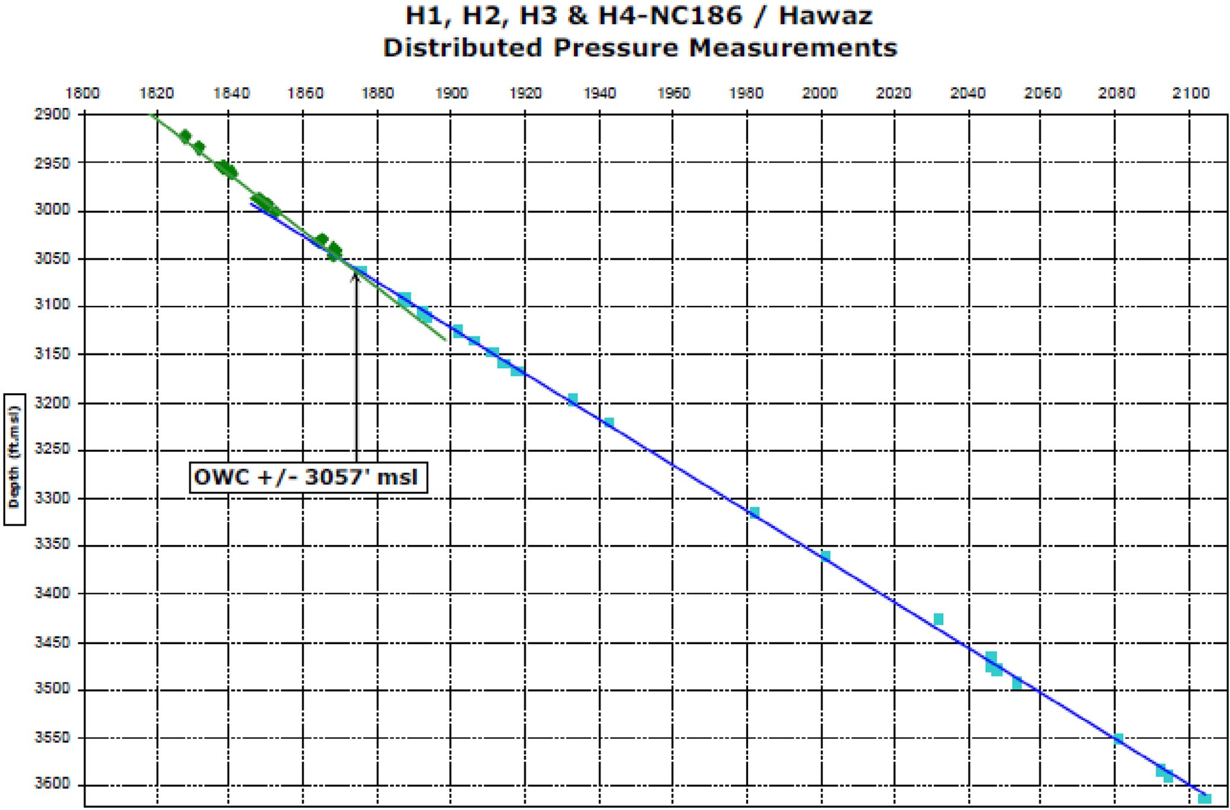

**Fig. 7 – Reservoir pressure gradient based on data from H1, H2, H3 and H4-NC186 wells.**

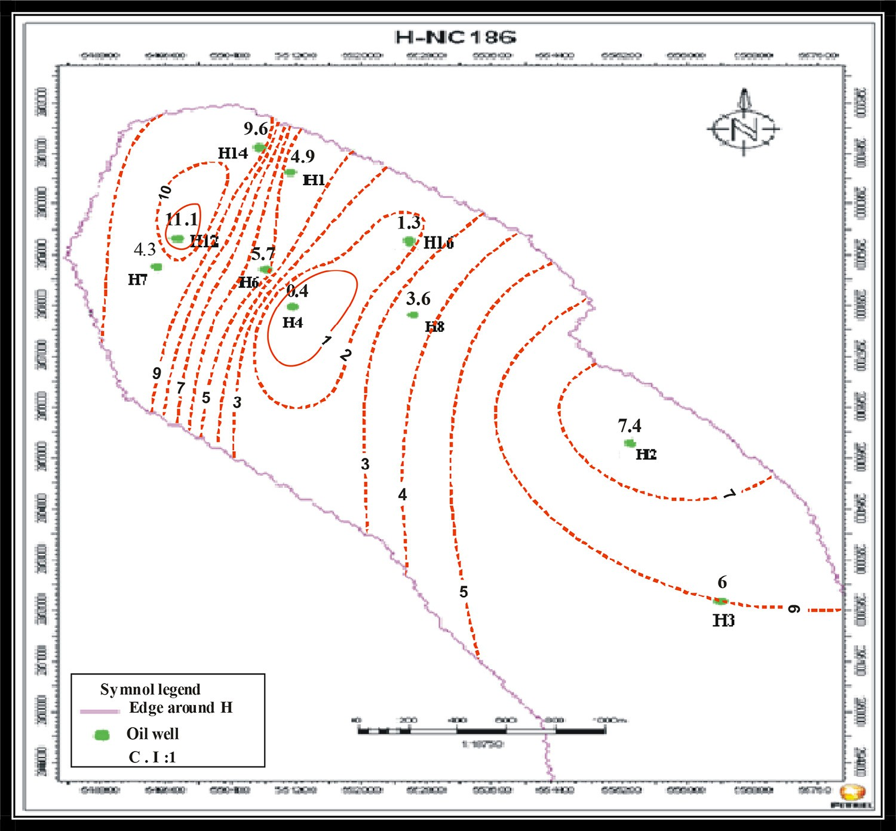

**Fig. 8 – Average shale Indicator (Ish) contour map for H oil field.**

**2  86  0.43

200

0.43

(7)

water (Kro and Krw) and calculating water cut (WC). Many tech- niques were presented to calculate this parameter. Asquith and Gibson [12] have proposed calculating Swirr for each zone de-

*w*  0.433  1.0 g/cc

The above calculated densities correspond to oil (0.8 g/cc) and fresh water (1.0 g/cc) bearing zones.

pending on formation factor F:

*Swirr* 

*F*

2000

(8)

## *Presence of shale and its effect on permeability*

The shale indicator has been calculated for Hawaz reservoir using gamma ray log (Fig. 8). The results indicated that these values are very low. This proves that this reservoir is clean and this is well supported by the core data of vertical (Kv) and hori- zontal (Kh) permeabilities when they have been plotted for horizons H5 and H6 of H4 well (Fig. 9), which has an average shale indicator (Ish) of 0.4 in the whole horizons of reservoir. The majority of the plotted points are related to a straight line with 45° slope (i.e. Kv = Kh), indicating that the reservoir is clean, highly porous and permeable.

## *Irreducible water saturation*

The estimation of Swirr can be beneficial in extracting valu- able description of the reservoir parameters, especially in exploratory wells, where core data are not available. It is the cornerstone for evaluating relative permeabilities to oil and

The authors applied the above equation for Hawaz forma- tion in H1-NC186 well and displayed the results in a set of crossplots between Sw, Swirr, and ΦN-D as follows.

## *Relative permeability to water and oil*

The relationship between Sw and Swirr can be used to evalu- ate graphically the relative permeability to water (Krw), as illustrated in Fig. 10. According to this plot, a set of points plotted on and below the zero line reflects no water production. These points reflect the irreducible state of the reservoir (i.e. Sw = Swirr). Points plotted on and below the 0.01 line (i.e. 1% water production) belongs also to the horizons H4–H6. Points located on a higher value line represent the deeper horizon (H8). On the other hand, the relative permeability to oil (kro) is inversely proportional to that of water (Krw). This is clear in Fig. 11, which represents the relationship between Sw and Swirr as a function of (Kro) for H1-NC186 well. Points of zero Krw are plotted here on and around 1.0 Kro line (i.e. 100%

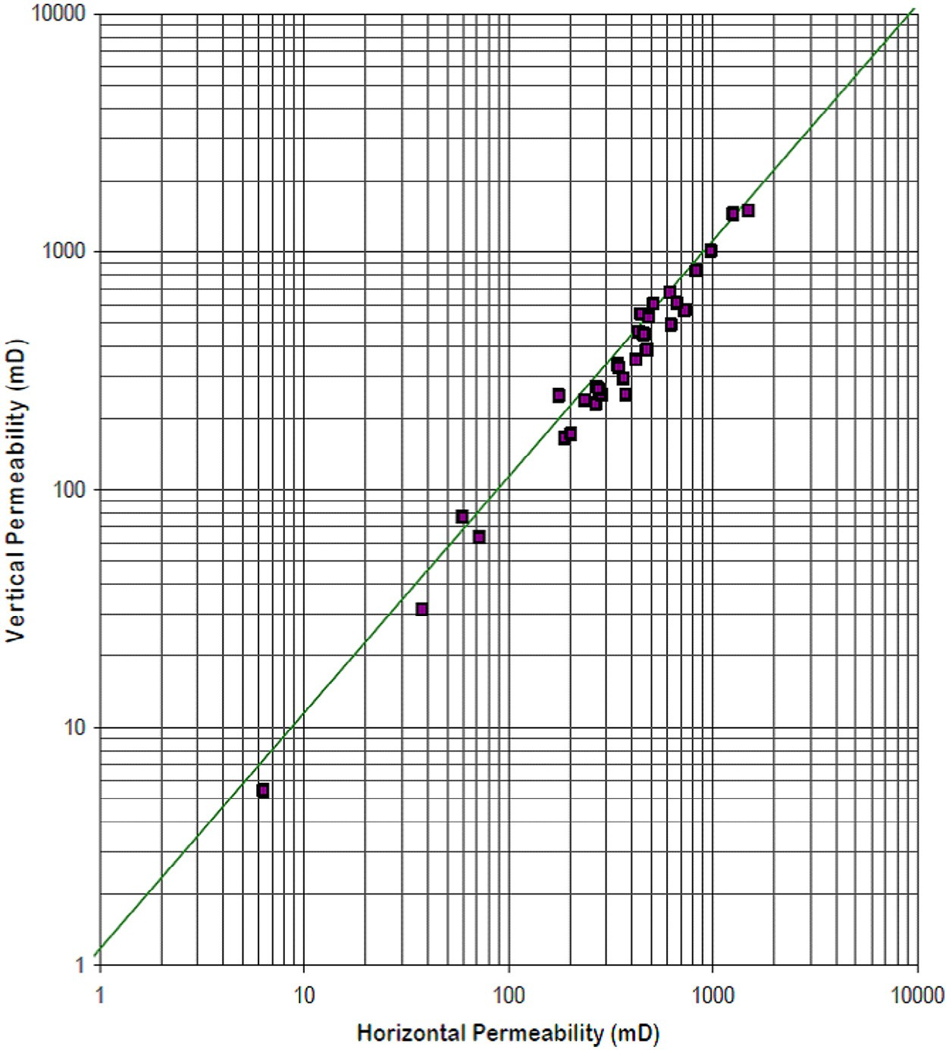

**Fig. 9 – Core horizontal permeability (Kh) versus vertical permeability for Hawaz formation, horizons H5 and H6 in H4- NC186 well.**

relative permeability to oil and zero relative permeability to water) to represent the top horizons H4–H5. The percent of water which was produced with oil is of prime importance to de- scribe the reservoir performance. Fig. 12 represents the water cut (WC) lines in respect to Sw versus Swirr for H1-NC186 well. The WC% should be compatible with the above Krw and Kro values. This is obvious since the plotted points on and above the zero WC line (blue points), related to horizons H4–H6, have Krw = 0 and Kro = 1.0. Yellow points that belong to horizons H7 and H8 are located above the 60% WC line, corresponding to deeper horizons with Kro less than 0.1.

## *Hydraulic flow unit (HFU)*

suggesting the possible existence of 4 hydraulic flow units cor- responding to these trends.

## *Pickett crossplot*

The Pickett plot, devised by Pickett [13], represents one of the simplest and most effective methods in use. It solved Ar- chie’s equation differently and plotted deep resistivity and porosity, both on logarithmic scales. In the Pickett plot, the water saturation lines are parallel. Substituting the Archie equation solution for water saturation and rearranging the relation- ship becomes:

The relationship between permeability (K) and porosity (Φ) is

log   log *Rt*  *m* log *Sw*  log *arw*

(9)

not straightforward. There is no specifically defined trend line between K and Φ values. It is possible to have a very high Φ without having any K at all, such as pumice, clays and shales. The reverse of high K with low Φ might also be true such as micro-fractured carbonate. Accordingly, there is no well defined universal correlation between K and Φ. Different Φ–K relation- ships are evident from the existence of different hydraulic

flow units (HFU). This situation is obvious for Hawaz forma- tion in the study area as the reservoir is clean homogeneous sandstone. Four distinct and clear trend curves are detected

between core K–Φ on a semi-log crossplot (Fig. 13) of H12 well,

This technique is based on observation that true resistiv- ity (Rt) is a function of porosity (Ø), water saturation (Sw) and cementation factor (m). The straight line (100% water satura- tion) represents wet resistivity (R0). The slop of this line is 1/m. It intercepts a resistivity value equals to Rw. Fig. 14 displays Pickett plot for H1-NC186 well. The slope of the parallel (Sw)

lines is equal to 1.9, which means that cementation factor (m) is equal to 1.9. Lines representing constant (ρma–ρb)(Sw) (i.e. BVW) values are parallel to the Y axis, which indicates that (m)

is equal to (n) as shown in the figure. The intercept of the R0 line with the horizontal axis is at 0.2, which represents (aRw).

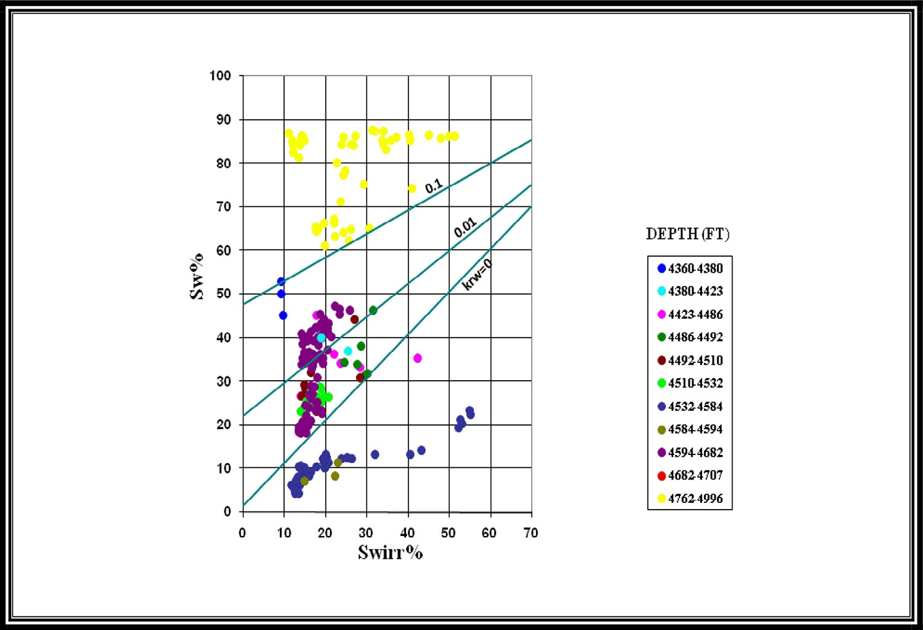

**Fig. 10 – Crossplot between Sw versus Swirr for Hawaz formation, H1-NC186 well showing relative permeability to water (Krw).**

Accepting the value of 0.62 for (a) gives Rw that is equal to

0.32 Ω·m. The available core data for H1-NC186 well supports the validity of the results obtained from the Pickett plot for this well. The core Rw is 0.3 Ω·m, which matches very well with that obtained from the Pickett plot (0.32 Ω·m). Also, core results for this well gave (n) equal to 1.71, which closely correlated with

1.9 that was obtained from the Pickett plot.

## *Buckles plot*

The product of a formation’s water saturation (Sw) and its po- rosity (Φ) is the bulk volume of water (BVW). If values for BVW calculated at several depths in a formation are constant or very close to constant (i.e. Φ·Sw = constant), this indicates that the zone is of a single rock type and at irreducible water saturation

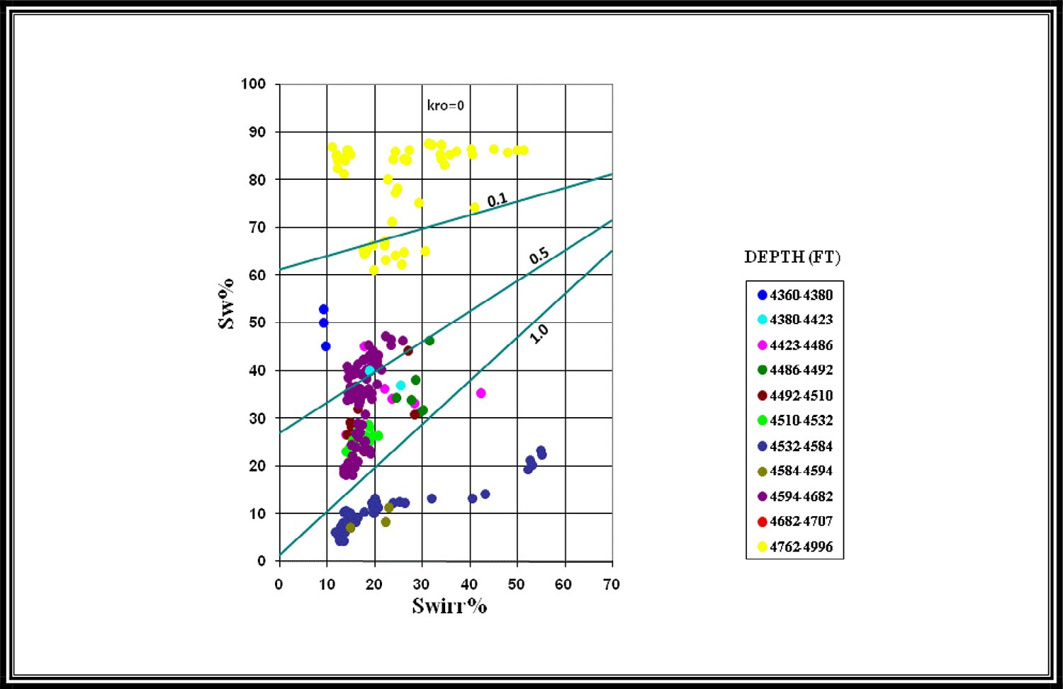

**Fig. 11 – Crossplot between Sw versus Swir for Hawaz formation, H1-NC186 well, displaying relative permeability to oil (Kro).**

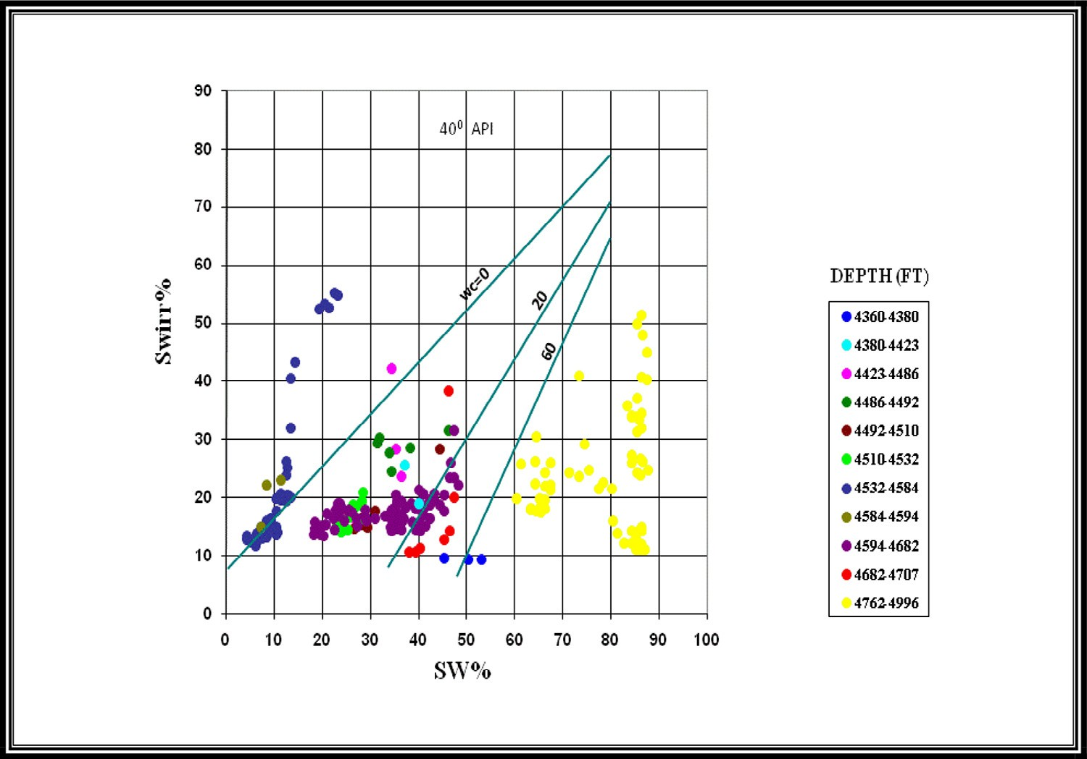

**Fig. 12 – Crossplot between Sw and Swirr for Hawaz formation, H1-NC186 well, illustrating water cut percent.**

(Swirr); water in the invaded zone does not move because it is held on grains by capillary pressure (Pc). Accordingly, the ex- pected production is hydrocarbon free of water [14]. The Buckles plot is a graphical representation of Φ versus Sw. Points of equal BVW will fall on the hyperbolic curve across this plot. If BVW is plotted using data from a reservoir at irreducible water satu- ration (Swirr), the points fall along a single hyperbolic curve. Fig. 15 illustrates Buckles plot for horizon H5 of H12 well. This figure indicates that this horizon has a good quality reservoir.

The plotted points display two trends, one at irreducible state and followed distinctive hyperbolic curve equal to 0.034. The other random trend follows scattered points, reflecting water production only. This plot may also indicate the presence of more than one hydraulic flow units (HFU). According to the value of BVW, this horizon has medium to fine grain sand sizes based on the slandered values given by Asquith and Gibson

[12] and this is confirmed by the available core description by Repsol Oil Operation [2].

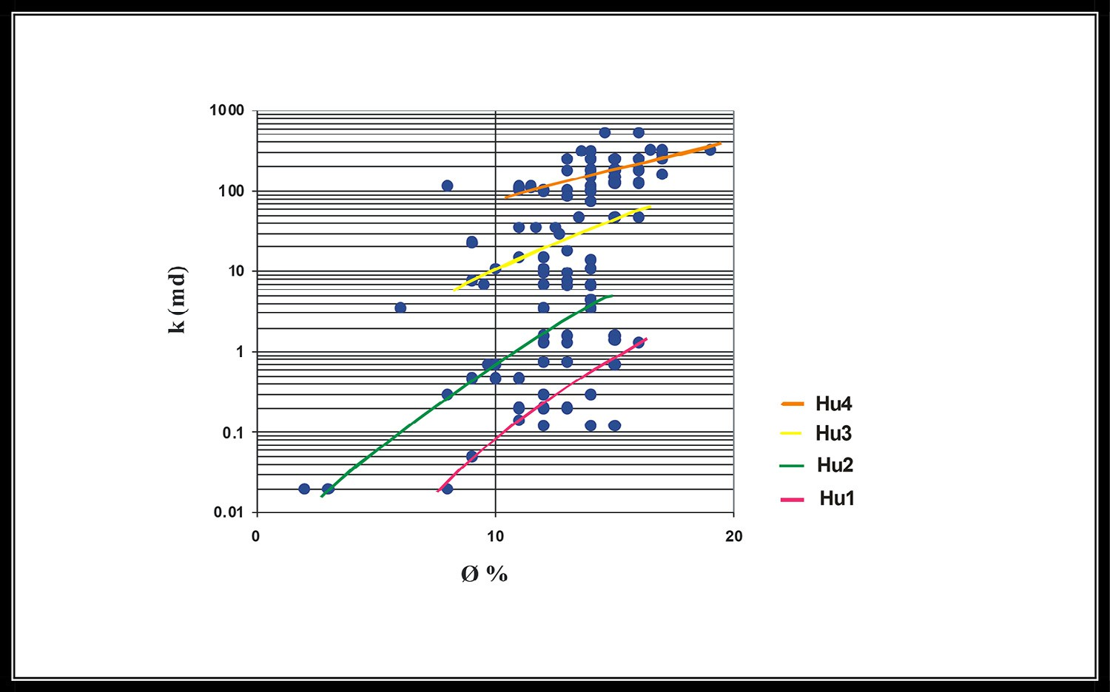

**Fig. 13 – Core permeability (Kmd) versus porosity (**Φ **%) for Hawaz formation, H12-NC186 well.**

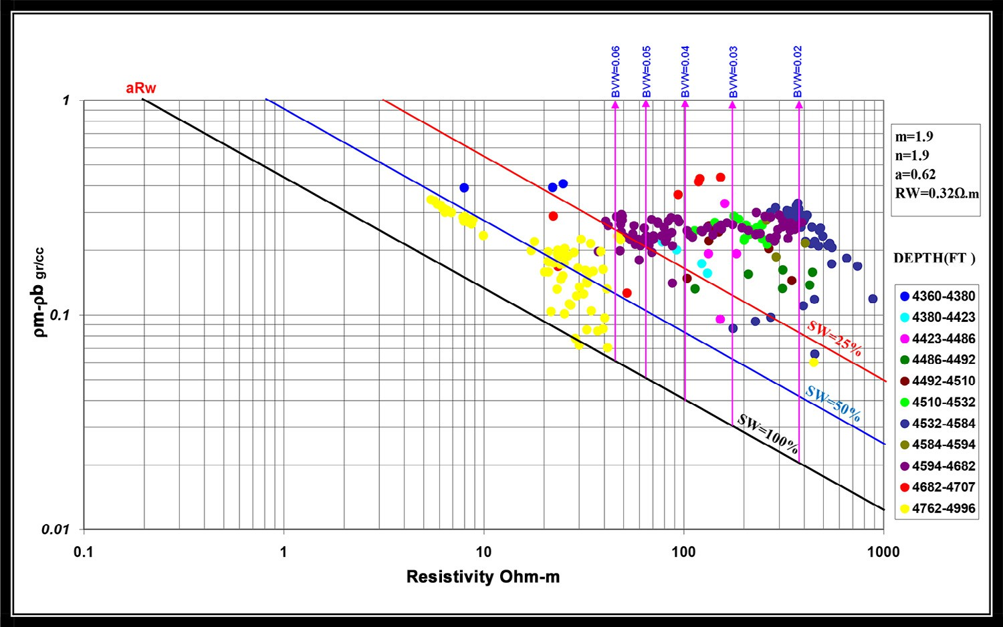

**Fig. 14 – Pickett plot between (**ρ**ma–**ρ**b) versus Rt on log-log plot for H1-NC186 well.**

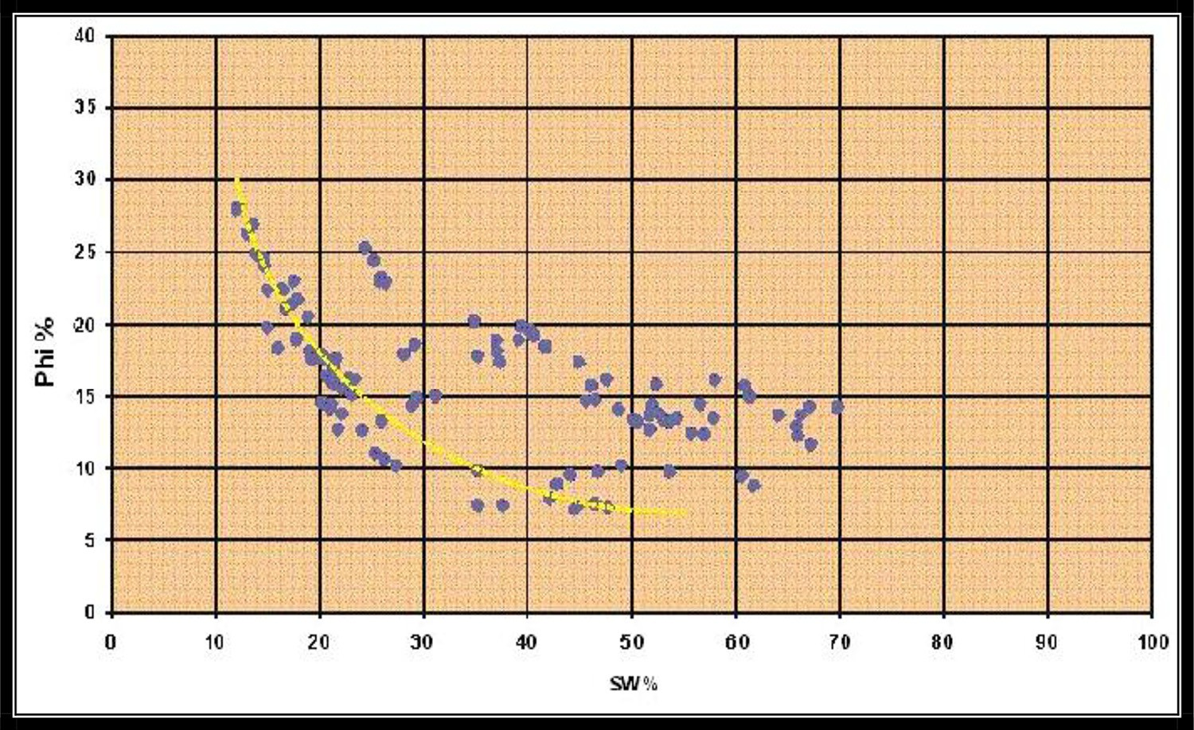

**Fig. 15 – Buckles plot between water saturation (Sw) and neutron-density derived porosity for Hawaz reservoir, horizon (H5) in H12-NC186 well.**

# Discussion and conclusion

The petroleum system is represented in H field by structural Hawaz paleo-high created during the post-Hawaz erosional event. The main regional seal is the Silurian Tanezzuft shale formation. The basal Tanezzuft hot shale member acts also as the main source rock in the area of study. The Hawaz forma- tion of Middle Ordovician age represents the main reservoir. This formation is informally subdivided into 8 horizons, named H1 to H8. Some units have been subdivided into sub-units. Each horizon is characterized by its own petrophysical parameters.

The quick look interpretation, which is the main purpose of well logging data, and their output calculations with crossplots are investigated. They are highly concordant with the core petrophysical parameters such as Rw and Sw values ,which give more support and validation of the quick look method in H field. The calculated density indicates that this reservoir is only oil–water bearing zone. The pressure data of H1, 2, 3 and 4 wells follow the same trend lines; it indicates that Hawaz reservoir is hydraulically connected. The shale indicator of that reservoir is low, elucidating that it is probably clean, highly porous and permeable. The relationship between core K–Φ and also Buckles crossplot suggests the presence of more than one

hydraulic flow units of Hawaz formation. The analysis has shown the importance of the horizons H4–H6 as oil bearing zones, while H7–H8 zones are water bearing horizons.

R E F E R E N C E S

1. [Thomas D. Geology Murzuq oil development could boost S.](http://refhub.elsevier.com/S2314-808X(16)30021-5/sr0010)

[W. Libya prospects. Oil Gas J 1995;41–6.](http://refhub.elsevier.com/S2314-808X(16)30021-5/sr0010)

1. [Repsol Oil Operation. Field H development plan, Repsol](http://refhub.elsevier.com/S2314-808X(16)30021-5/sr0015) [exploration Murzuq. 2005. SA (Internal report).](http://refhub.elsevier.com/S2314-808X(16)30021-5/sr0015)
2. [Selim EI, Kamel A, Kashlaf A. Hydrocarbon probability of](http://refhub.elsevier.com/S2314-808X(16)30021-5/sr0020) [middle Ordovician Hawaz formation, Murzuq basin,](http://refhub.elsevier.com/S2314-808X(16)30021-5/sr0020) [southwestern Libya. Arab J Geosci 2015;8:5531–60.](http://refhub.elsevier.com/S2314-808X(16)30021-5/sr0020)
3. [Bellini E, Massa D. A stratigraphic contribution to the](http://refhub.elsevier.com/S2314-808X(16)30021-5/sr0025) [Palaeozoic of southern basins of Libya. In: Salem MJ,](http://refhub.elsevier.com/S2314-808X(16)30021-5/sr0025) [Busrewil MT, editors. The geology of Libya, vol. I. London:](http://refhub.elsevier.com/S2314-808X(16)30021-5/sr0025) [Academic Press; 1980. p. 3–56.](http://refhub.elsevier.com/S2314-808X(16)30021-5/sr0025)
4. [Conant LC, Goudarzi GH. Stratigraphic and tectonic](http://refhub.elsevier.com/S2314-808X(16)30021-5/sr0030) [framework of Libya. Am Assoc Petr Geol Bull 1967;51:719–](http://refhub.elsevier.com/S2314-808X(16)30021-5/sr0030) [30.](http://refhub.elsevier.com/S2314-808X(16)30021-5/sr0030)
5. [Clark-Lowes DD. New geological concepts in the evaluation](http://refhub.elsevier.com/S2314-808X(16)30021-5/sr0035) [of the Southern Basins of Libya, with particular reference to](http://refhub.elsevier.com/S2314-808X(16)30021-5/sr0035) [the Al Shara¯ rah Trend of the Murzuq Basin. Geology of](http://refhub.elsevier.com/S2314-808X(16)30021-5/sr0035) [southern Libya, Sl, 176. 2012.](http://refhub.elsevier.com/S2314-808X(16)30021-5/sr0035)
6. [Howard JD, Reineck RE. Depositional facies of high-energy](http://refhub.elsevier.com/S2314-808X(16)30021-5/sr0040) [beach-to-offshore sequence: comparison with low energy](http://refhub.elsevier.com/S2314-808X(16)30021-5/sr0040) [sequence. Am Assoc Petr Geol Bull 1981;65:807–30.](http://refhub.elsevier.com/S2314-808X(16)30021-5/sr0040)
7. [Pierobon ES. Contribution to the stratigraphy of the Murzuq](http://refhub.elsevier.com/S2314-808X(16)30021-5/sr0045) [Basin, SW Libya. In: Salem MJ, Belaid MN, editors. The](http://refhub.elsevier.com/S2314-808X(16)30021-5/sr0045) [geology of Libya, vol. V. London: Academic Press; 1991.](http://refhub.elsevier.com/S2314-808X(16)30021-5/sr0045)

[p. 1767–84.](http://refhub.elsevier.com/S2314-808X(16)30021-5/sr0045)

1. [Echikh K, Sola MA. Geology and hydrocarbon occurrences in](http://refhub.elsevier.com/S2314-808X(16)30021-5/sr0050) [the Murzuq Basin, SW Libya. In: Sola MA, Worsley D, editors.](http://refhub.elsevier.com/S2314-808X(16)30021-5/sr0050) [Geological exploration in Murzuq Basin. Amsterdam:](http://refhub.elsevier.com/S2314-808X(16)30021-5/sr0050) [Elsevier Science; 2000. p. 175–222.](http://refhub.elsevier.com/S2314-808X(16)30021-5/sr0050)
2. [Bertello F, Fattorini A, Visentin C. Hydrocarbon discoveries](http://refhub.elsevier.com/S2314-808X(16)30021-5/sr0055) [and remaining potential of the Paleozoic play of the Murzuq](http://refhub.elsevier.com/S2314-808X(16)30021-5/sr0055) [Basin, Libya. In: AAPG Hedberg conference “Paleozoic and](http://refhub.elsevier.com/S2314-808X(16)30021-5/sr0055) [Triassic Petroleum Systems in North Africa”, February 18–20,](http://refhub.elsevier.com/S2314-808X(16)30021-5/sr0055) [2003, Algiers, Algeria. 2003.](http://refhub.elsevier.com/S2314-808X(16)30021-5/sr0055)
3. [Basal AM. Well log response as a guide for detecting the](http://refhub.elsevier.com/S2314-808X(16)30021-5/sr0060) [hydrocarbon density and saturation, with computed](http://refhub.elsevier.com/S2314-808X(16)30021-5/sr0060) [confidence factor. AIN SHAMS Sci Bull 1994;32:329–52.](http://refhub.elsevier.com/S2314-808X(16)30021-5/sr0060)
4. [Asquith G, Gibson C. Basic well log analysis for geologists.](http://refhub.elsevier.com/S2314-808X(16)30021-5/sr0065) [Tulsa, OK: The American Association of Petroleum Geologist;](http://refhub.elsevier.com/S2314-808X(16)30021-5/sr0065) [2004.](http://refhub.elsevier.com/S2314-808X(16)30021-5/sr0065)
5. [Pickett GR. A review of current techniques for determination](http://refhub.elsevier.com/S2314-808X(16)30021-5/sr0070) [of water saturation from logs. JPT (NOV.) 1425–33. 1966.](http://refhub.elsevier.com/S2314-808X(16)30021-5/sr0070)
6. [Morris RL, Biggs WP. Using log-derived values of water](http://refhub.elsevier.com/S2314-808X(16)30021-5/sr0075) [saturation and porosity. In: 8th Ann. Logging Symp. Trans.](http://refhub.elsevier.com/S2314-808X(16)30021-5/sr0075) [Paper O, Soc. Professional Well Log Analysts (SPWLA); 1967.](http://refhub.elsevier.com/S2314-808X(16)30021-5/sr0075)